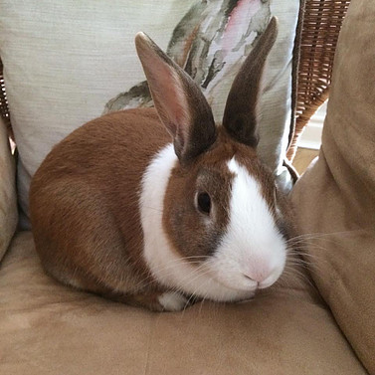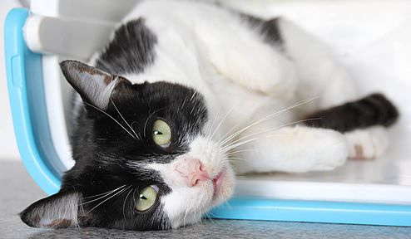

**Help save more animals.**

When you adopt from us you are helping to free up valuable space for another animal who is in need of our care. Most rescue centres are full to the brim and have long waiting lists so every animal who is adopted helps to provide room for one more who needs us. Adopting from us also helps to create less demand for shop bought and bred animals meaning less will suffer from commercial breeding programs.

If you are interested then please call us and leave a message on 01908 611179. One of our volunteers will call you back when they can. Alternatively you can contact us by email [cathome@mkrspca.org.uk](mailto:cathome@mkrspca.org.uk?subject=Enquiry)

**Used to being handled.**

While in our care we regularly handle our animals. This ongoing care is already provided by our loving volunteers. There are some that will need extra special care and we will fully advise you prior to adoption on what the animals needs are, which brings us to....

**Free lifetime advice!**

We offer advice and support to all owners of our adopted animals. This is an ongoing service and provided completely free of charge!

**Save money!**

Adopting is cheaper than buying - yes it's true! Pet shops and breeders often charge a lot of money. When your pet has matured you will need to pay to have it neutered. This can cost another large sum of money. When you adopt from us you are asked to make a small donation and your pet has already been neutered* saving the worry and the cost!

**Already litter trained.**

Our animals are usually already accustomed to using a litter tray.

*\*Kittens are not neutered*

Why Adopt?